Chapter 10, Problem 79.

For the op amp circuit in Fig. 10.122, obtain v_{o}(t).
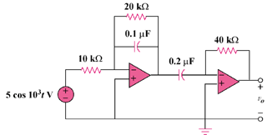

Figure 10.122
For Prob. 10.79.

